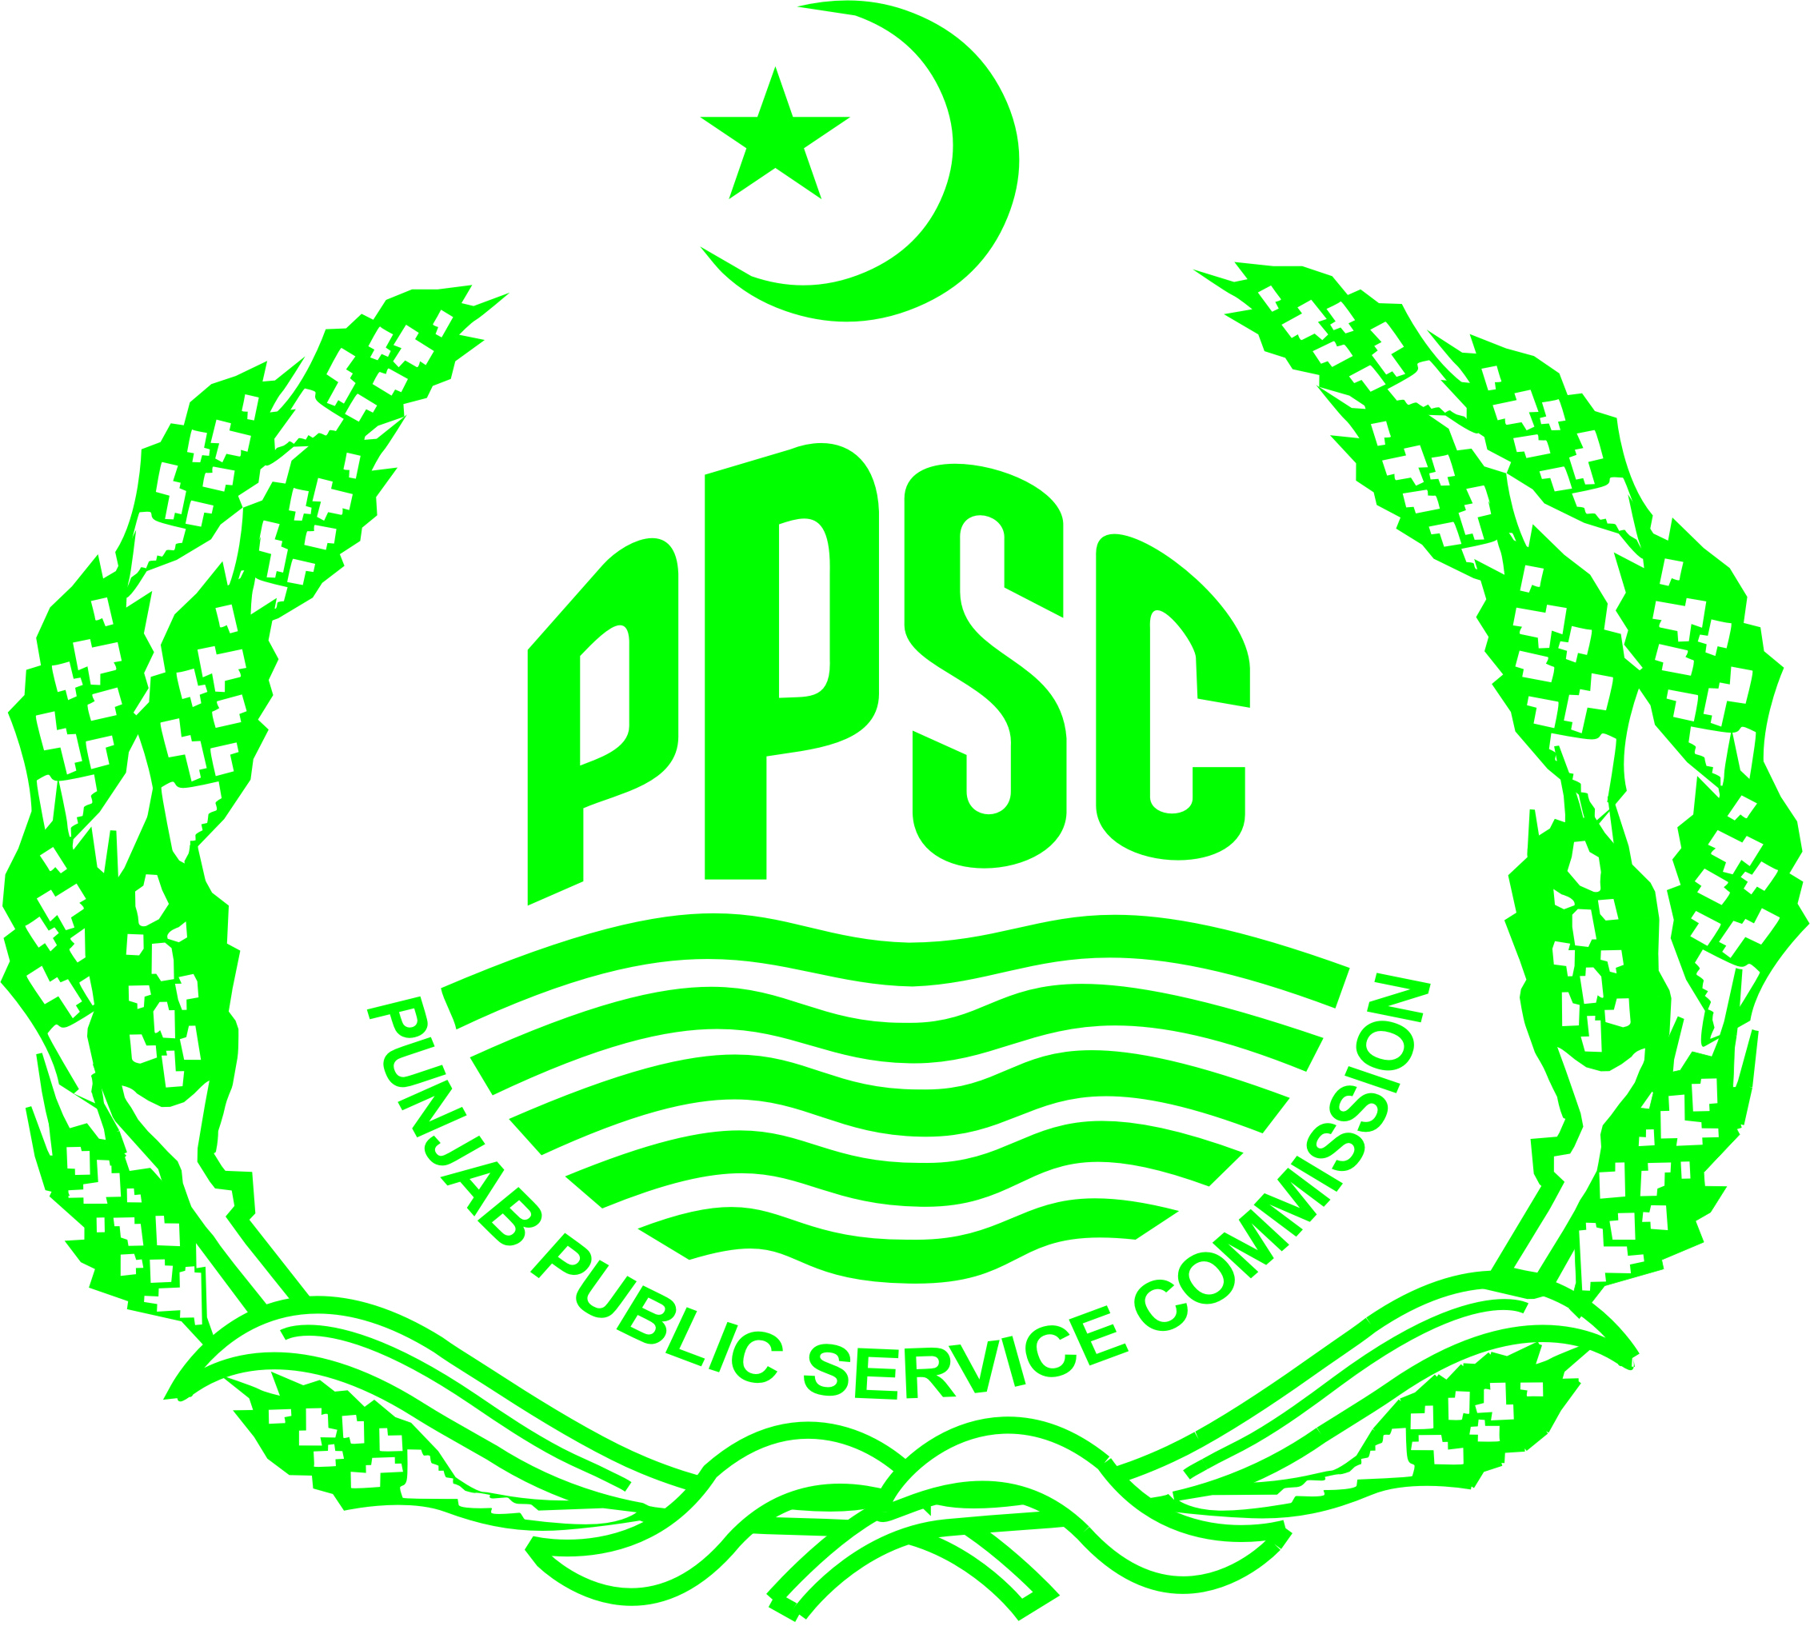 | PUNJAB PUBLIC SERVICE COMMISSION, LAHORE  WRITTEN TEST FOR THE POSTS OF CHIEF OF SECTIONS/EDO , 2016.

NOTICE

The Punjab Public Service Commission announces that the following 10 candidates for recruitment to TWO 02 PERMANENT POSTS OF CHIEF OF SECTIONS/EDO (F&P)/DIRECTOR (DEVELOPMENT & FINANCE) (BS-19) IN THE PUNJAB, (P&D) LAHORE, 2016 have been provisionally cleared for Interview as a result of written test held on 05-06-2016.
2. Call up letters for Interview will be uploaded on the website of the PPSC very soon. Candidates will also be informed through SMS and Email.
3. The candidates will be interviewed, if they are found eligible at the time of Interview as per duly notified conditions of Advertisement & Service Rules. It will be obligatory for the candidates to bring academic certificates and related documents at the time of Interview as being intimated to them through PPSC Website, SMS and Email shortly.

SR.  NO. | ROLL  NO. | DIARY  NO. | NAME OF THE CANDIDATE | FATHER'S NAME
1 | 10031 | 72400126 | AAMIR SHAHZAD | MAHAR KHAN
2 | 10051 | 72400105 | AMJAD KHAWAR HAYAT CHEEMA | SANA ULLAH CHEEMA
3 | 10067 | 72400158 | FAROOQ IRSHAAD | IRSHAAD AHMAD
4 | 10075 | 72400247 | HAFIZ MUHAMMAD IQBAL | MUKHTAR AHMAD
5 | 10092 | 72400184 | ISMAT ULLAH | ALLAH BAKHSH
6 | 10099 | 72400240 | KHALIQ DAD GONDAL | ALLAH BUKHSH
7 | 10238 | 72400248 | YASIR MUBEEN | MUNAWAR ALI
8 | 10242 | 72400132 | ZAHEER-UD-DIN BABUR | MUHAMMAD NAJAM-UD- DIN
9 | 10414 | 72400094 | IMTIAZ AHMED | IHSAN UL HAQ
10 | 10517 | 72400032 | MUHAMMAD MUBASHER | MUHAMMAD ASHRAF WATTOO

4. This Result intimation is issued, errors and omissions excepted, as a notice only. An entry appearing in it does not itself confer any right or privilege independently for any claim for final selection.
5. The candidates who have qualified the written test for interview must submit photocopy set of their related documents within 02 days after the date of declaration of result for the said post.
NOTE:
The candidates who have failed to qualify for the Interview can download their provisional result intimation cards from PPSC website (ppsc.gop.pk) by clicking Single Paper DMC Button.

Case No. 1K2016

Dated: 10-06-2016
Secretary

